Are streaming services killing music?
By The Philadelphia Inquirer, adapted by Newsela staff
11.12.14

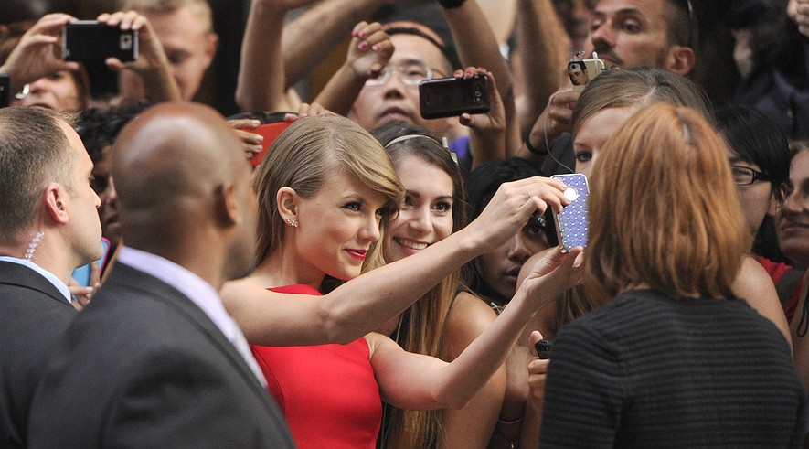
Listeners are faced with a decision. Should they stream their music on Spotify? Or buy it in stores or on iTunes?
Taylor Swift made news recently by pulling her music off Spotify, the world’s biggest streaming music service. Back in July, Swift was plotting her current pop-music takeover with her album, "1989." In its first week, Swift sold 1.3 million copies of her new album.
Even with the chaos of her album launch, she took time out to write an opinion article for the Wall Street Journal. Widely mocked as young and naive at the time, the 24-year-old songwriter used the national newspaper to share her hopeful view. “The music industry is not dying ... it’s just coming alive,” she wrote.
Easy for her to say, some grumbled. She just sold more albums in a week than anyone since Eminem in 2002.

Swift's "1989" Sales
To get a sense of her success, consider this: In the week before the release of "1989," the top 200 albums on the Billboard chart sold a combined total of 1.53 million copies, barely outpacing "1989."
Swift’s upbeat attitude surely comes from her own position, not to mention her sharp focus on achieving sales goals through bonding with her fans on social media like Instagram and Twitter.
However, in the Wall Street Journal piece, Swift had important points to make about the business of music.
“Music should not be free,” she insisted. Swift's music has made her quite a bit of money. So far in 2014, she’s made $64 million, according to Forbes magazine. She will make plenty more through download sales on iTunes.
For every dollar fans spend downloading Swift's music, she gets 70 cents. When fans stream her music on Spotify, however, she gets less than a penny per song.
Many in the music industry see streaming as the only hope for growth. People used to have to buy music, first on giant records, then on tapes or CDs. Then with the Internet, people were able to get music for free online, costing musicians a lot of money.

Spotify's Tiny Payouts
According to the Recording Industry Association of America (RIAA), money from streaming on YouTube, Pandora and Spotify has helped by bringing in more money. They argue that there would have already been fewer paid downloads in 2014. It has also stopped people from illegally downloading the music for free.
Still, the tiny Spotify payouts have led to a growing number of major acts to take down some or all of their music from the service, like artists from Beyoncé to the Beatles.
Patrick Carney, from a rock group called the Black Keys, argued against the service. “My whole thing about music is: If somebody’s making money, then the artist should be getting a fair cut of it,” he told the Seattle Times.
Carney said that Spotify's CEO, Daniel Ek, is richer than former Beatle Paul McCartney, even though "he’s 30 and he’s never written a song.”
This week R&B star Aloe Blacc also gave his opinion, writing an anti-streaming piece for Wired magazine. It tweeted out the headline: “I support Taylor Swift — streaming services are killing music.”
In her opinion article last summer, Swift wrote: “Music is art, art is important and rare. Important, rare things are valuable. Valuable things should be paid for.” Swift's idea is noble. It would be easier to live by if the Internet had never happened. Of course, if the Internet had never happened, Swift wouldn’t have 46 million followers.

A Thorny Problem
But Swift’s larger point is correct. If they can afford to, musicians shouldn’t cheapen their music by just giving it away. She wrote that she hopes artists don’t “underestimate themselves or undervalue their art.”
For smaller bands trying to make money, keeping their music off streaming services is not so easy. These less known bands need to get their music out any way they can. If they’re going to make money, people need to be able to hear them easily.
To stream or not to stream is a thorny problem for fans, too. The streaming model lets the industry own the music you listen to. Rather than letting you own your collection, the music business is moving toward a model similar to on-demand cable TV or Netflix. Every song ever written is (theoretically) available whenever and wherever. The catch is that you, the user, pay each time.
Having millions of songs available and trying to decide what to click on can be a hard choice to make. And it’s not good for the kind of close bonding with a favorite artist that comes when you care about something enough to actually buy it.
That’s one reason live performance has become so important. Bands can make money by putting on concerts, but it also gives fans a chance to make a human connection with the artists they love.
Swift has proved herself an expert at forging those connections. And with her pulling her music off Spotify, she strengthens her bond with her followers. They have to buy her album to prove how much they love her.

Central Ideas
- Taylor Swift is leading the charge against Spotify because she thinks it devalues music.
- The main problem with Spotify is that it pays artists a penny or less per song.
- There is more to music than playing a song from a giant catalog, such as the connection artists make with fans.

